**[27] Design Turing Machine Simulation Which Accepts Palindrome String CDC**

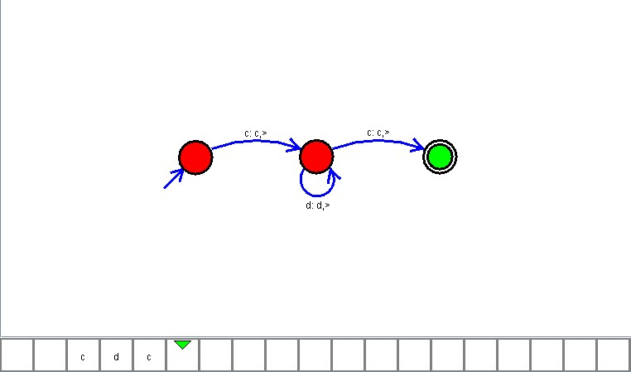

**Result**

The TM is designed to compute the given string as input using Simulator